

Software Requirements Specification
for Workly – Home Service Provider Platform

Project Title: Workly – Home Service Provider Platform
Module Code: CSC 2032 – Object Oriented Programming
Sathira Sugeesvara | AS20240401
W.H.D Wickramasinghe | AS2040514

1. Introduction ..................................................................................... 3
1.1 Purpose ...................................................................................... 3
1.2 Scope ......................................................................................... 3
1.3 Definitions, Acronyms and Abbreviations ............................................... 3
1.4 References ................................................................................... 4
1.5 Document Overview .......................................................................... 4

2. Overall Description ............................................................................ 5
2.1 Product Perspective ........................................................................ 5
2.2 Product Functions .......................................................................... 5
2.3 User Classes and Characteristics ................................................... 6
2.4 Operating Environment ..................................................................... 6
2.5 Design Constraints ......................................................................... 7
2.6 Assumptions and Dependencies ........................................................ 7

3. System Requirements ............................................................................ 8
3.1 Functional Requirements .................................................................. 8
3.2 Non-Functional Requirements ......................................................... 11

4. UML Diagrams ..................................................................................... 13
4.1 Use Case Diagram ........................................................................... 13
4.2 Class Diagram ............................................................................... 14
4.3 Sequence Diagram ............................................................................ 15
4.4 Activity Diagram ............................................................................ 16

5. Future Enhancements ............................................................................ 17

6. Conclusion ......................................................................................... 18

7. References ......................................................................................... 19

1. Introduction
1.1 Purpose
The purpose of this Software Requirements Specification (SRS) document is to define the functional and non-functional requirements of the Workly – Home Service Provider Platform. This document serves as a guide for the development team by clearly describing the system's objectives, features, constraints, and expected behavior.
Workly is designed to connect customers with trusted service providers, such as electricians, plumbers, carpenters, and cleaners, through a user-friendly web application. The system enables customers to search for services, make bookings, and manage appointments, while allowing service providers to manage their profiles, services, and booking requests. Administrators are provided with tools to manage users, monitor the platform, and maintain overall system performance.
This document is intended for developers, project supervisors, testers, and stakeholders to ensure a common understanding of the system requirements throughout the software development lifecycle.

1.2 Scope
Workly is a web-based home service provider platform designed to connect customers with skilled service providers in a simple, secure, and efficient manner. The system enables users to search for various household services, view provider profiles, book services, and manage their bookings through an intuitive interface.
The platform supports three main user roles: Customers, Service Providers, and Administrators. Customers can register, log in, browse available services, make bookings, and submit ratings and reviews after a completed service. Service providers can create and manage their profiles, list the services they offer, update their availability, and accept or reject booking requests. Administrators are responsible for managing users, monitoring bookings, approving memberships, and ensuring the smooth operation of the platform.
The system is developed using React for the frontend, Spring Boot for the backend, and MongoDB as the database, providing a modern, responsive, and scalable architecture.
The current scope of the project focuses on service discovery, booking management, user management, membership management, and administrative functions. Advanced features such as online payment processing, real-time messaging, GPS tracking, and mobile applications are considered future enhancements and are not included in the current version of the system.

1.3 Definitions, Acronyms and Abbreviations
Term / Acronym | Definition
SRS | Software Requirements Specification, a document that defines the functional and non-functional requirements of a software system.
UI | User Interface, the visual interface through which users interact with the system.
API | Application Programming Interface, a set of rules that allows communication between the frontend and backend.
REST API | Representational State Transfer Application Programming Interface, used for communication between the client and server over HTTP.
JWT | JSON Web Token, a secure token used for user authentication and authorization.
CRUD | Create, Read, Update, and Delete operations performed on system data.
MongoDB | A NoSQL document-oriented database used to store application data.
React | A JavaScript library used to build the frontend user interface.
Spring Boot | A Java-based framework used to develop the backend services of the application.
Admin | The system administrator responsible for managing users, services, memberships, and overall platform operations.
Customer | A registered user who searches for, books, and reviews services.
Service Provider | A registered professional who offers services, manages bookings, and updates service information.
Booking | A request made by a customer to hire a service provider for a specific service.
Membership | A subscription plan that provides additional features or benefits to service providers.
HTTP | Hypertext Transfer Protocol, the communication protocol used between the client and server.
HTTPS | Hypertext Transfer Protocol Secure, the encrypted version of HTTP that provides secure communication.

1.4 References

The following references were used in the design and development of the Workly – Home Service Provider Platform:
[1] IEEE Computer Society, IEEE Recommended Practice for Software Requirements Specifications (IEEE Std 830-1998).
[2] React Documentation. Available: https://react.dev/
[3] Spring Boot Documentation. Available: https://spring.io/projects/spring-boot
[4] MongoDB Documentation. Available: https://www.mongodb.com/docs/
[5] Oracle Java Documentation. Available: https://docs.oracle.com/
[6] Tailwind CSS Documentation. Available: https://tailwindcss.com/docs
[7] Vite Documentation. Available: https://vitejs.dev/
[8] JSON Web Token (JWT). Available: https://jwt.io/

1.5 Document Overview
This Software Requirements Specification (SRS) document is organized into several sections to provide a clear understanding of the Workly – Home Service Provider Platform.
Section 1 introduces the purpose, scope, definitions, references, and overall structure of the document.
Section 2 provides an overview of the system, including its product perspective, main functions, user classes, operating environment, design constraints, and assumptions.
Section 3 describes the system requirements, including both functional and non-functional requirements.
Section 4 presents the UML diagrams used to illustrate the system design, such as the Use Case Diagram, Class Diagram, Sequence Diagram, and Activity Diagram.
Section 5 discusses potential future enhancements that may be incorporated into later versions of the system.
Section 6 concludes the document by summarizing the system and its objectives.
Section 7 lists the references used during the preparation of this document.

2. Overall Description
2.1 Product Perspective
Workly is a web-based home service provider platform designed to simplify the process of connecting customers with skilled service professionals. The system acts as an online marketplace where customers can search for service providers, view their profiles, make bookings, and manage service requests efficiently.

The platform supports three primary user roles: Customer, Service Provider, and Administrator. Customers can browse available services, book appointments, and provide ratings and reviews. Service providers can manage their profiles, list their services, respond to booking requests, and monitor their bookings. Administrators oversee the entire platform by managing users, memberships, bookings, and system operations.

Workly is developed using a modern three-tier architecture. The frontend is built with React to provide a responsive and user-friendly interface. The backend is developed using Spring Boot, which handles business logic and RESTful APIs. MongoDB is used as the database to store user information, service details, bookings, memberships, and reviews.

The system is designed to be scalable, secure, and easy to maintain, allowing new features and services to be added in future versions without significant changes to the existing architecture.

2.2 Product Functions
The Workly – Home Service Provider Platform provides a comprehensive set of features to simplify the process of connecting customers with professional service providers. The main functions of the system are as follows:
• User Registration and Authentication
- Allows customers and service providers to create accounts and securely log in using authenticated credentials.
• User Profile Management
- Enables users to view, update, and manage their personal information and account details.
• Service Management
- Allows service providers to create, update, and manage the services they offer, including service descriptions, pricing, and availability.
• Service Search and Browsing
- Enables customers to browse available services and search for service providers based on categories and service types.
• Booking Management
- Allows customers to request service bookings, while service providers can accept, reject, or complete booking requests.
• Membership Management
- Enables service providers to apply for membership plans and allows administrators to review and manage membership requests.
• Review and Rating System
- Allows customers to submit ratings and reviews for completed services to help maintain service quality.
• Administrative Management
- Enables administrators to manage users, services, bookings, memberships, and monitor overall system activities.
• Secure Access Control
- Implements JWT-based authentication and role-based authorization to ensure secure access to system resources.

2.3 User Classes and Characteristics
The Workly – Home Service Provider Platform consists of three primary user classes, each with different roles and responsibilities within the system.

• Customer
Customers are registered users who use the platform to search for service providers, view service details, make bookings, manage their appointments, and submit ratings and reviews after receiving a service. Customers are expected to have basic knowledge of using web applications.
• Service Provider
Service providers are registered professionals who offer various home services through the platform. They can create and manage their profiles, add or update service listings, respond to booking requests, manage appointments, and maintain their membership status. Service providers should be familiar with managing online service requests.
• Administrator
Administrators are responsible for managing and maintaining the overall operation of the platform. They can manage user accounts, oversee bookings, review membership requests, monitor services, and ensure the security and proper functioning of the system. Administrators are expected to have sufficient technical knowledge to perform administrative tasks effectively.

2.4 Operating Environment

The Workly – Home Service Provider Platform is a web-based application designed to operate in a modern client-server environment. The system is developed using current web technologies to ensure reliability, scalability, and ease of maintenance.
The operating environment includes:
• Frontend
- React.js
- Vite
- HTML5
- CSS3
- JavaScript

• Backend
- Java 21
- Spring Boot Framework

• Database
- MongoDB Atlas

• Web Browser
- Google Chrome
- Mozilla Firefox
- Microsoft Edge

• Development Tools
- Visual Studio Code
- IntelliJ IDEA
- Git and GitHub

2.5 Design Constraints

The development and implementation of the Workly – Home Service Provider Platform are subject to the following design constraints:
• The system is developed as a web-based application using React for the frontend, Spring Boot for the backend, and MongoDB Atlas as the database.
• User authentication and authorization are implemented using JSON Web Tokens (JWT) to ensure secure access to the system.
• The application requires a stable internet connection for communication between the client, server, and database.
• The system is designed to support modern web browsers such as Google Chrome, Mozilla Firefox, and Microsoft Edge.
• The application follows a client-server architecture to separate the presentation layer, business logic, and data management.
• The project is developed using Java 21 and must remain compatible with the selected development frameworks and libraries.
• The current version of the system does not include advanced features such as online payment processing, real-time messaging, GPS tracking, or a mobile application.

2.6 Assumptions and Dependencies
The successful operation of the Workly – Home Service Provider Platform is based on the following assumptions and dependencies:
• Users have access to a stable internet connection and a modern web browser to use the system.
• Customers, service providers, and administrators are expected to provide accurate and valid information during registration and profile management.
• The application depends on the availability of the MongoDB Atlas database for storing and retrieving system data.
• The system relies on the Spring Boot backend to process requests and provide RESTful API services to the frontend.
• JWT-based authentication is used to ensure secure user authentication and authorization.
• The application depends on third-party libraries and frameworks, including React, Spring Boot, MongoDB, and Vite, for its development and operation.
• The system assumes that users have basic knowledge of using web applications and internet-based services.
• Any interruption to the internet connection, server, or database may temporarily affect the availability of the system.

3. System Requirements
3.1 Functional Requirements
The Workly – Home Service Provider Platform shall provide the following functional requirements:
FR-01: The system shall allow users to register as either a Customer or a Service Provider.
FR-02: The system shall allow registered users to log in securely using their email address and password.
FR-03: The system shall authenticate users using JSON Web Tokens (JWT) and provide role-based access to system features.
FR-04: The system shall allow users to view and update their profile information.
FR-05: The system shall allow service providers to create, edit, and delete service listings.
FR-06: The system shall allow customers to browse and search for available services by category or service type.
FR-07: The system shall allow customers to view detailed information about service providers and the services they offer.
FR-08: The system shall allow customers to book services by selecting a provider and a preferred date and time.
FR-09: The system shall allow service providers to accept, reject, or complete booking requests.
FR-10: The system shall allow customers to view, cancel, and track the status of their bookings.
FR-11: The system shall allow service providers to manage their membership subscriptions.
FR-12: The system shall allow customers to submit ratings and reviews after a completed service.
FR-13: The system shall allow administrators to manage user accounts, including viewing, updating, and removing users when necessary.
FR-14: The system shall allow administrators to manage bookings and monitor platform activities.
FR-15: The system shall allow administrators to review and manage membership requests submitted by service providers.
FR-16: The system shall store and retrieve all application data securely using MongoDB.
FR-17: The system shall provide appropriate success and error messages for user actions.

3.2 Non-Functional Requirements
The Workly – Home Service Provider Platform shall satisfy the following non-functional requirements:
NFR-01: Performance
The system shall respond to user requests within a reasonable time under normal operating conditions.
NFR-02: Security
The system shall provide secure user authentication using JSON Web Tokens (JWT) and protect user data from unauthorized access.
NFR-03: Reliability
The system shall operate consistently with minimal failures and ensure the integrity of stored data.
NFR-04: Availability
The system shall be accessible to users whenever the application server and database are operational.
NFR-05: Usability
The system shall provide a simple, user-friendly, and responsive interface that is easy to navigate.
NFR-06: Maintainability
The system shall be designed using a modular architecture to simplify future maintenance, testing, and feature enhancements.
NFR-07: Scalability
The system shall support the addition of new users, services, and features without significant changes to the existing architecture.

NFR-08: Compatibility
The system shall function correctly on modern web browsers, including Google Chrome, Mozilla Firefox, and Microsoft Edge.
NFR-09: Data Integrity
The system shall ensure that user information, bookings, and service records are stored accurately and consistently within the database.
NFR-10: Portability
The system shall be deployable on different operating systems and server environments with minimal configuration changes.

4. UML Diagrams
4.1 Use Case Diagram
The Use Case Diagram illustrates the interactions between the three primary actors of the Workly platform — Customer, Service Provider, and Administrator — and the core functionalities offered by the system. It provides a high-level view of how each user role engages with the platform's features, based directly on the functional requirements defined in Section 3.1.
The Customer actor represents registered users who search for services, view service provider profiles, book appointments, track the status of their bookings, and submit ratings and reviews after a service is completed.
The Service Provider actor represents registered professionals who manage their service listings, respond to incoming booking requests by accepting, rejecting, or completing them, and manage their membership subscription on the platform.
The Administrator actor represents the system's platform managers, responsible for managing user accounts, monitoring and overseeing bookings, reviewing service provider membership requests, and ensuring the overall smooth operation of the system.
Three use cases — Register Account, Login, and Manage Profile — are shared across all three actors, since authentication and profile management are common to every user role. The diagram also models two standard UML relationships to capture dependencies between use cases:
Book Service includes Login, since a customer must be authenticated before a booking can be made.
Submit Rating & Review extends Complete Booking, since a review can only be submitted once a booking has been marked as completed by the service provider.
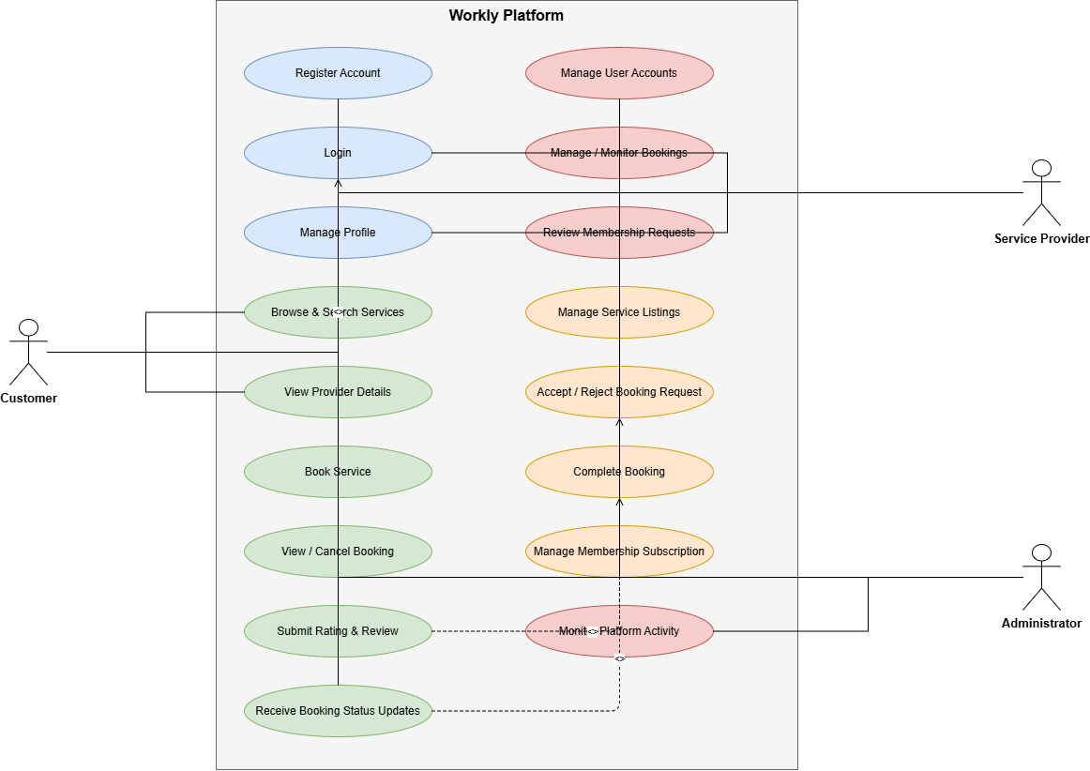
Together, these use cases and relationships summarize the complete set of interactions supported by the Workly platform across all user roles.

4.2 Class Diagram
The Class Diagram represents the static structure of the Workly system, showing the core entity classes, their attributes, and the relationships between them. The design reflects standard object-oriented principles, particularly inheritance and encapsulation, and is directly based on the system's actual data model.
At the center of the design is the abstract User class, which defines the attributes common to every account on the platform — full name, email, password, role, and audit timestamps. Three classes inherit from User through generalization: Customer, ServiceProvider, and Admin. Each subclass extends the shared user data with attributes specific to its role. Customer adds contact and address details along with a gender attribute. ServiceProvider adds the same contact details in addition to a list of skills, the services offered, and a verification status used to confirm that a provider has been approved by an administrator. Admin extends User with only an administrator identifier, since administrative accounts require no additional profile data.
The Service class represents an individual entry in the platform's service catalog, defined by a category, title, description, and icon, independent of any specific provider.
The Booking class is the central entity linking the other classes together. Rather than embedding full object references, a Booking stores the identifiers and denormalized names of the associated Customer, ServiceProvider, and Service — a deliberate design choice suited to the document-oriented structure of MongoDB, allowing booking records to be read efficiently without repeated lookups. Each Booking also stores scheduling information, the service address, notes, the amount charged, and its current status.
Three enumerations support the class model: Role, which distinguishes Customer, Provider, and Admin accounts; Gender, used by both Customer and ServiceProvider; and BookingStatus, which defines the lifecycle of a booking as it moves from Pending through Accepted or Rejected, and ultimately to Completed or Cancelled.
Together, these classes form the complete data model underlying the Workly platform's booking, service management, and user administration functionality.

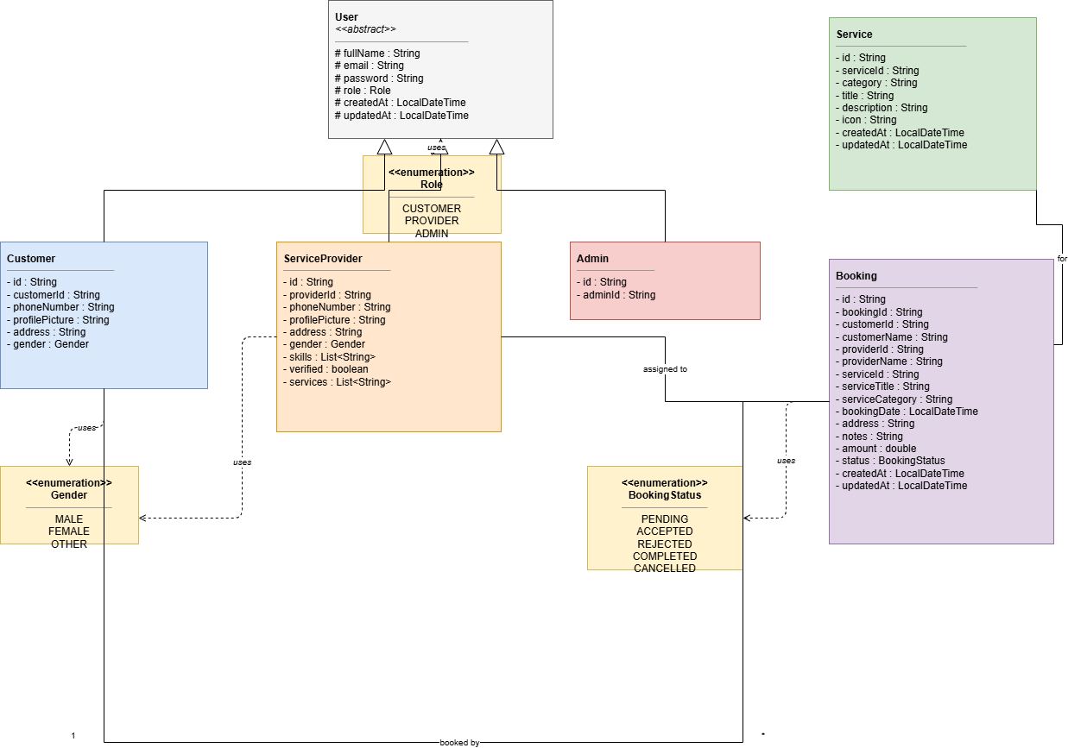

4.3 Sequence Diagram
The Sequence Diagram illustrates the flow of interactions between the system components during the booking process, from the moment a customer submits a booking request to the moment a service provider responds to it. It captures the actual request flow implemented in the system: Customer, Frontend, BookingController, BookingService, MongoDB, and Provider.
The diagram is divided into two parts. The first part shows the booking creation flow. The customer selects a service provider and a service, and submits a booking request through the frontend. The frontend sends this request to the BookingController, which delegates the operation to the BookingService. The BookingService validates that the referenced customer, provider, and service all exist, constructs a new Booking object with an initial status of Pending, and persists it to MongoDB. A BookingResponse is then returned back through the controller and frontend layers, and the customer is shown a booking confirmation.
The second part, enclosed in an alt frame, represents the provider's response to the booking. The service provider views their pending job requests, which are retrieved from MongoDB through the same controller-service-repository chain. When the provider chooses to accept or reject a booking, the frontend sends a status update request to the BookingController, which calls the BookingService to verify that the provider owns the booking and that the requested status change is a valid transition before saving the update to MongoDB. The updated booking status is then returned to the frontend, and the customer is notified of the outcome.
This diagram demonstrates the layered architecture of the Workly backend, where the Controller layer handles HTTP requests, the Service layer enforces business rules such as ownership verification and status transition validation, and the Repository layer manages persistence with MongoDB.
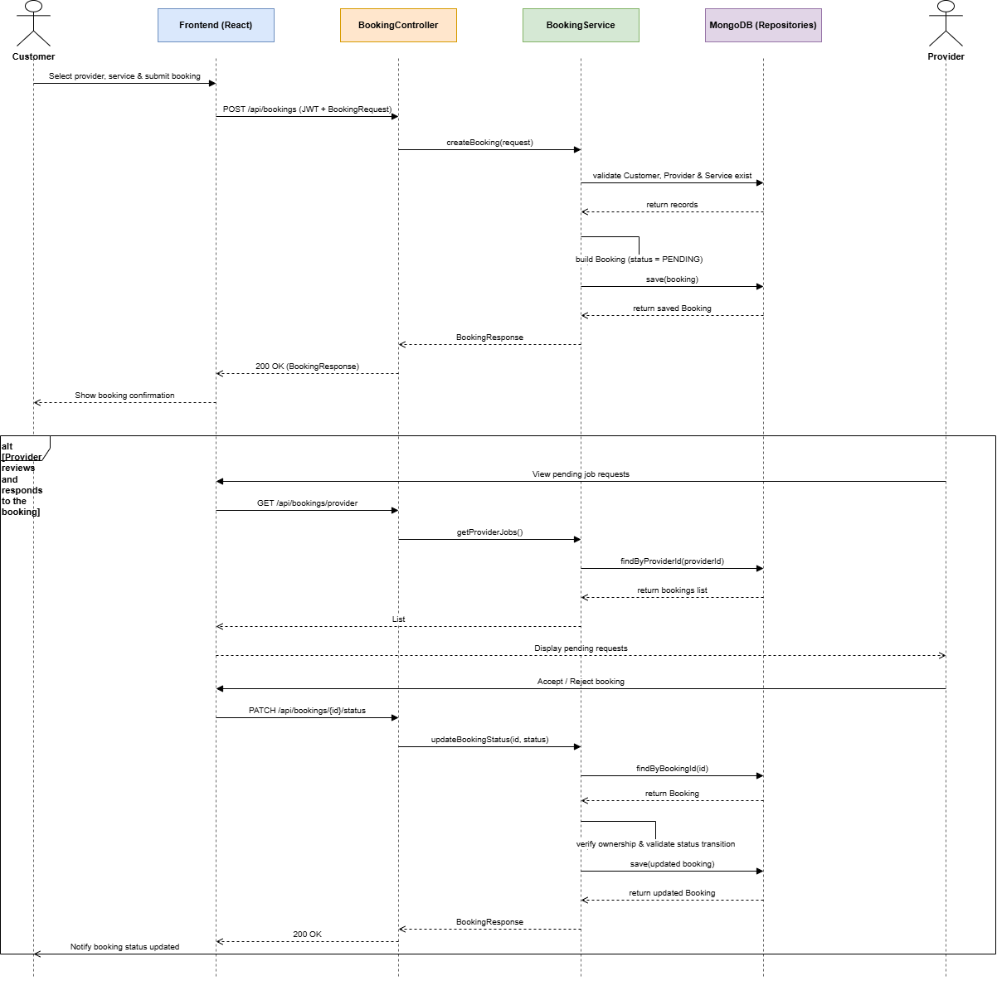

4.4 Activity Diagram
The Activity Diagram models the complete workflow of the booking process using swimlanes to separate the responsibilities of the Customer, the System (frontend and backend combined), and the Service Provider. It illustrates not only the sequence of actions but also the decision points that determine how the flow proceeds, based on the actual booking status state-machine implemented in the system.
The flow begins when the customer browses available services and providers, selects a provider and service, and submits a booking request. The system authenticates the request and validates that the referenced customer, provider, and service all exist. If validation fails, the system returns an error response and the flow ends. If validation succeeds, the system creates a new booking with a status of Pending, saves it to the database, and notifies the provider of the new request.
The service provider then reviews the booking request and decides whether to accept or reject it. If the provider rejects the request, the system updates the booking status to Rejected, notifies the customer, and the flow ends. If the provider accepts the request, the system updates the booking status to Accepted and notifies the customer. The provider then carries out the service and marks the booking as completed, at which point the system updates the booking status to Completed and notifies the customer. Finally, the customer submits a rating and review for the completed service, which the system saves, bringing the flow to its end.
An additional note is included to reflect a supported alternative flow: a customer may cancel a booking at any point while it is in the Pending or Accepted state, which transitions the booking status directly to Cancelled and ends the flow, without the provider having accepted or completed the service.
This diagram demonstrates the complete decision logic governing a booking's lifecycle, directly reflecting the status transition rules enforced within the BookingService layer of the backend.

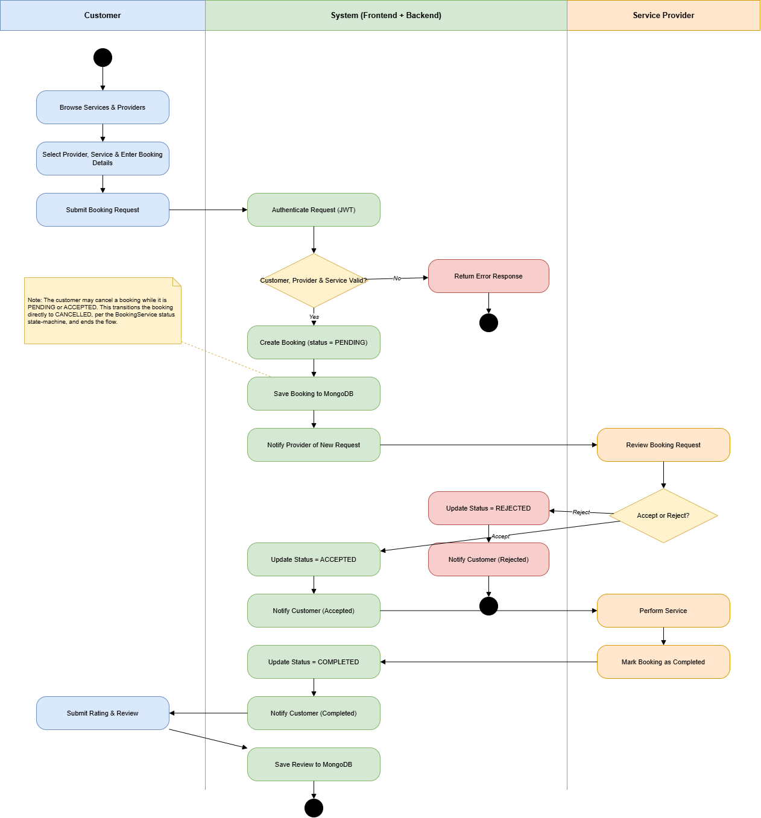

5. Future Enhancements
The current version of the Workly – Home Service Provider Platform provides the essential features required to connect customers with service providers. However, several additional features can be implemented in future versions to improve the functionality and user experience of the system.
The following enhancements are proposed for future development:
• Online Payment Integration
- Integrate secure online payment gateways to allow customers to make payments directly through the platform.
• Real-Time Chat
- Provide an in-app messaging system to enable direct communication between customers and service providers.
• Mobile Application
- Develop Android and iOS mobile applications to improve accessibility and convenience.
• AI-Based Service Recommendations
- Recommend suitable service providers based on customer preferences, booking history, and ratings.
• Advanced Search and Filtering
- Introduce additional search filters such as location, price range, availability, and provider ratings.
• Service Provider Verification
- Implement identity and document verification to increase trust and reliability within the platform.

These enhancements will improve the overall usability, security, scalability, and effectiveness of the Workly platform while providing a better experience for all users.

6. Conclusion

The Workly – Home Service Provider Platform is designed to provide a reliable and efficient solution for connecting customers with professional service providers through a web-based application. This Software Requirements Specification (SRS) document defines the functional and non-functional requirements, system features, user roles, and overall structure of the platform.

The system aims to simplify the process of discovering, booking, and managing home services while providing administrators with the necessary tools to manage users, memberships, and platform operations. By utilizing modern technologies such as React, Spring Boot, and MongoDB, Workly offers a scalable, secure, and user-friendly solution.

This document serves as a foundation for the design, development, testing, and future enhancement of the system. It ensures that all stakeholders have a clear understanding of the project requirements and objectives, supporting the successful implementation of the Workly platform.

7. References
[1] IEEE Computer Society, IEEE Recommended Practice for Software Requirements Specifications (IEEE Std 830-1998).
[2] React Documentation. Available: https://react.dev/
[3] Spring Boot Documentation. Available: https://spring.io/projects/spring-boot
[4] MongoDB Documentation. Available: https://www.mongodb.com/docs/
[5] Oracle, Java Documentation. Available: https://docs.oracle.com/
[6] Vite Documentation. Available: https://vitejs.dev/
[7] Tailwind CSS Documentation. Available: https://tailwindcss.com/docs
[8] JSON Web Token (JWT). Available: https://jwt.io/
[9] MDN Web Docs. Available: https://developer.mozilla.org/
[10] GitHub Documentation. Available: https://docs.github.com/
Repository Link:-
https://github.com/Sathirasugeesvara/Workly.git/

No | Name Of Dev | Work | Signature
01. | Sathira Sugeesvara | Frontend Implementation  Backend Implementation  API calling
02. | W.H.D. Wickramasinghe | Backend Implementation  Document prepairing  API calling

